

Extracorporeal Radial Shockwave Therapy Consent Form

Demographics: Date ________________

__________

Full Name _____________________________________ DOB ________________ Gender F M Other

Address ______________________________________________ City _______________ State __________ Zip ________

Phone Home _______________________ Cell _______________________ Work ______________________

(Please check where we can leave a detailed message of patient information during business hours)

Emergency Contact _________________________Relation _____________________ Phone ______________________

Are you currently enrolled in Medicare? Yes No

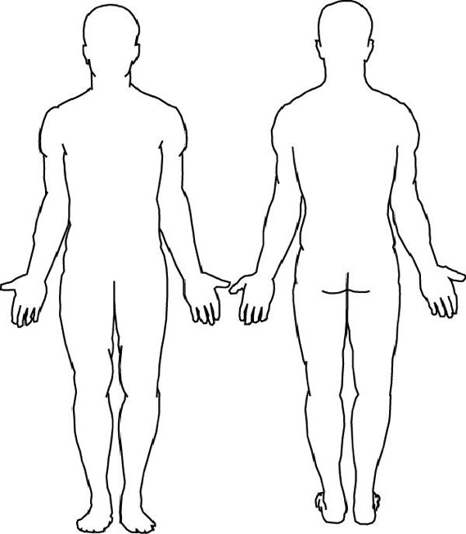Please review the following contraindications and check those which apply to you:

Please circle the area of your pain and rate your pain on a scale from 0 – 10 (0 being no pain, 10 being extreme pain:

Area 1: 0 1 2 3 4 5 6 7 8 9 10

Area 2: 0 1 2 3 4 5 6 7 8 9 10

Area 3: 0 1 2 3 4 5 6 7 8 9 10

|  |  |
| --- | --- |
|  | Coagulation disorders, thrombosis, heart or circulatory patients |
|  | Use of anticoagulants, especially Marcumar, Heparin, Coumadin |
|  | Tumor diseases, carcinoma, cancer patients |
|  | Pregnancy |
|  | Polyneuropathy in case of diabetes |
|  | Acute inflammations / pus focus in the target area |
|  | Children under the age of 16 or open growth plates |
|  | Cortisone therapy up to 6 weeks before first treatment |

Possible side effects:

* Swelling,
* reddening,
* hematomas,
* pain
* skin lesions after previous cortisone therapy

These side effects generally abate after 5 to 10 days. Pain can increase temporarily. Bruising and or swelling are also possible.

**I agree to Extracorporeal Shockwave Therapy and understand the risks and possible complications involved.**

**Bainbridge Island Physical Therapy reserves the right to charge a No Show fee of $125 should the client not show up to a scheduled appointment or cancel less than 4 hours in advance.**

Print Name__________________________ Signature________________________________________

Date____________________________